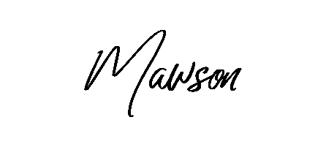
WHITE WINES
Sparkling wine (Please ask staff for our showcase wine) GLASS 10 / BOTTLE 42
Moonstruck Moscato (Vic) GLASS 10 / BOTTLE 40
Villa Jolanta Prosecco (Italy) GLASS 12 / BOTTLE 45
Oyster Bay Sauvignon Blanc (NZ) GLASS 11 / BOTTLE 42
Leogate Brokenback Pinot Gris (Hunter Valley) Award winner GLASS 10 / BOTTLE 40
John Wallace ‘Tilba’ Rose (Hunter Valley) Award winner GLASS 11 / BOTTLE 42
John Wallace ‘Sisters’ Chardonnay (Hunter Valley) Award winner GLASS 13 / BOTTLE 46

RED WINES
Tyrells Shiraz (Hunter Valley) GLASS 12 / BOTTLE 44
Devils Corner Pinot Noir (Tasmania) BOTTLE 48
Grant Burge Benchmark Merlot (S.A) GLASS 11 / BOTTLE 39
Angoves Family Crest Cabernet Sauvignon (Mclaren Vale) BOTTLE 38

COCKTAILS
Smiling Assassin 22
It will hit you where it needs too! Trust us!
Espresso Martini 20
Vodka, Kahlua, Fresh Espresso Shot, Sugar Syrup
Espresso Rich B*tch Martini 24
Vodka, Café Patron, Fresh Espresso Shot, Sugar Syrup
Toblerone Delight 23
Frangelico, Kahlua, Baileys, Cream, Honey
French Martini 19
Vodka, Chambord, Pineapple Juice
Coconut Margarita 20
Tequila, Triple Sec, Coconut Cream, Coconut Syrup, Lime Juice
Chilli or Classic Watermelon Margarita 20
Tequila, Triple Sec, Lime juice, Sugar Syrup, Watermelon Juice, Jalapeño
Lemon Splice 18
Vodka, Lemon Curd, Lemon Juice
Lavender Martini 18
Vanilla Vodka, Lavender Syrup, Lemon Juice
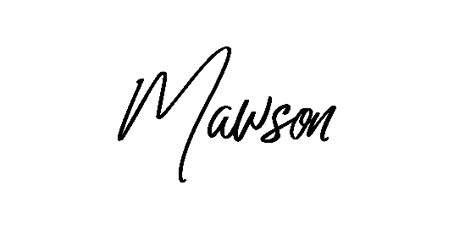
BOTTLED BEER $10
PALE ALE
150 Lashes
Stone & Wood *$12
LIGHT
James Boag Light
MID STRENGTH
Great Northern Super Crisp
FULL STRENGTH
Corona
Great Northern Original
Pure Blonde
Carlton Dry

SPIRITS (Price includes standard tall or short glass with soft drink or juice)
Vodka, Tequila, Pink Gin, Bacardi, Malibu, Baileys, Kahlua, Bundaberg Rum, Jim Beam, Jack Daniels, Canadian Club, Southern Comfort $12
Tanqueray Gin, Dewars Scotch Whiskey, Jameson Scotch Whiskey $13.50
Frangelico on Ice $8

*There will be more options available – just ask our friendly staff if there is something specific you are after.

